An Explainable Real-Time Driver Drowsiness Detection System Using Facial Geometry and Temporal Rules
Nguyen Bao Dang, Pham Vu Gia Kiet, Nguyen Xuan Binh*, and Ha Thuc Khuong Ninh
Department of Artificial Intelligence, FPT University, Ho Chi Minh City, Vietnam
ngxbinh9999@gmail.com
* Corresponding author.
Abstract. Camera-based driver monitoring requires temporal reasoning because normal blinks, speech-related mouth opening, and brief head movements may resemble fatigue cues in individual frames. This paper presents an explainable academic prototype that combines pretrained MediaPipe Face Mesh landmarks with Eye Aspect Ratio (EAR), Mouth Aspect Ratio (MAR), eye-line roll, and duration rules expressed in seconds. The method was evaluated on 41,793 DDD images, 1,448 full-face yawn/no-yawn images, and six self-recorded videos from three participants. On usable static images, the DDD experiment achieved 0.8701 precision and 0.4673 recall, whereas yawn detection at MAR achieved 1.0000 precision and 0.6551 recall. In video, event recall was 0.8000 for eye closure, 0.6000 for yawning, and 0.5000 for lateral head tilt. Participant-specific results varied substantially because recording and annotation protocols were not standardized. The results show that second-based temporal tracking supports videos with different frame rates, but fixed thresholds, roll-only head geometry, and limited participant coverage prevent safety-critical deployment.
Keywords: Driver drowsiness detection · Facial landmarks · Eye Aspect Ratio · MediaPipe Face Mesh · Temporal reasoning

1 Introduction
Driver drowsiness is a safety-relevant condition that cannot be inferred reliably from a single visual observation. A normal blink, a speech-related mouth opening, or a short head movement can resemble a fatigue cue in an isolated frame. Camera- based monitoring is nevertheless attractive for an academic prototype because it is contactless and can produce interpretable evidence from the eyes, mouth, and head [9].
This work investigates a lightweight alternative to training a project-specific drowsiness classifier. MediaPipe Face Mesh provides pretrained facial landmarks, while project-defined geometric measurements and temporal rules determine the warning state. Measuring persistence in seconds rather than by a fixed number of frames is important because the submitted videos have different frame rates. The system is evaluated on public static images and continuous videos, with results reported at frame, event, aggregate, and participant levels.
The practical contributions are: (i) integration of EAR, MAR, and lateral head roll in one real-time pipeline; (ii) duration tracking shared by webcam inference and offline evaluation; (iii) reproducible sample subsets for submission smoke tests; and (iv) explicit analysis of threshold trade-offs, participant variation, and failure cases. The system is an explainable course prototype rather than a certified vehicle-safety device.

2 Related Work
Driver-drowsiness monitoring methods are commonly grouped into physiological, vehicle-based, and behavioural approaches [9]. Camera- based behavioural systems can measure several facial cues without wearable sensors. Sigari et al. combined eyelid, PERCLOS, and head-orientation information within a driver face-monitoring system [10]. Their work supports multi-cue monitoring but also indicates that a single observable signal is not sufficient in all conditions.
Soukupová and Čech introduced the six-landmark EAR formulation for blink analysis [11]. Alioua et al. used mouth motion across consecutive frames for yawning-based fatigue detection [2]. Both approaches motivate the combination of interpretable facial geometry with temporal continuity rather than isolated frame decisions.
MediaPipe provides a low-latency framework for perception pipelines [6]. Its monocular Face Mesh method estimates a dense facial surface with 468 landmarks [4], while Attention Mesh improves landmark quality in semantically important eye and lip regions [3]. In the present project, these pretrained methods are used only for landmark extraction; the drowsiness decisions are produced by explicit ratios, an angle, and duration rules.
Recent systems increasingly combine eye, mouth, and head information. Zhu et al. used facial video sequences with EAR, MAR, PERCLOS, and landmarks [12]. Albadawi et al. supplied eye, mouth, and head-pose features to machine-learning classifiers [1]. Kim et al. combined landmark-based eye-closure detection with head-pose recognition and temporal continuity [5]. The present work does not propose a new landmark model or claim state-of-the-art performance. Its focus is transparent integration, second-based timing, and multi-level evaluation of a small academic prototype.

3 Proposed Method

3.1 System Overview
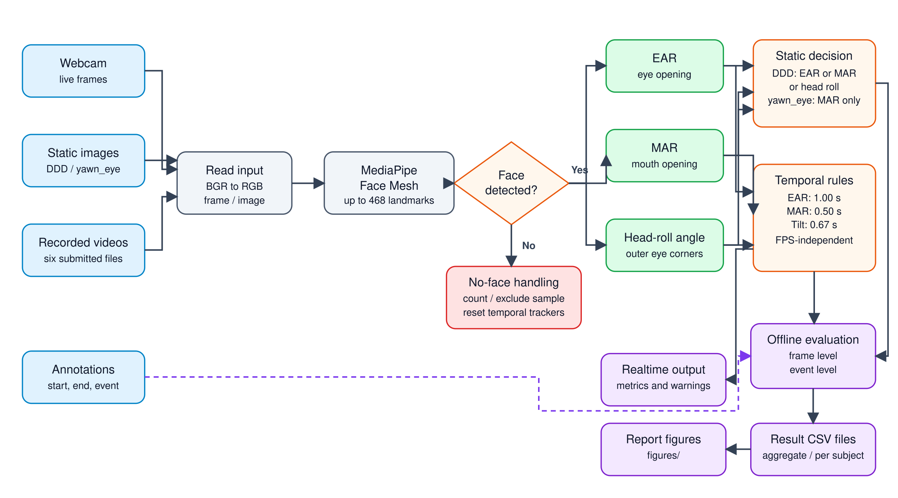
Fig. 1. Pipeline from image, video, or webcam input through Face Mesh, geometric cues, temporal rules, real-time warning, and offline evaluation.
Figure 1 summarizes the processing pipeline. Webcam frames, recorded videos, or static images are converted from BGR to RGB and processed by MediaPipe Face Mesh. If a face is found, the system computes EAR, MAR, and an eye-line roll angle. Static images use instantaneous geometric decisions. Webcam and video modes additionally require each condition to remain continuously true for its configured duration. A no-face frame is counted during evaluation and resets active temporal trackers.

3.2 Geometric Features
Six landmarks are used for each eye: left $\{33,160,158,133,153,144\}$ and right $\{362,385,387,263,373,380\}$. For eye points $p_{1},…,p_{6}$, EAR is
$$EAR=\frac{∥p_{2}−p_{6}∥_{2}+∥p_{3}−p_{5}∥_{2}}{2∥p_{1}−p_{4}∥_{2}}.$$ (1)
The two eye values are averaged; a smaller EAR indicates greater closure. Mouth landmarks $\{78,308,13,14\}$ represent the corners and upper/lower lip centres:
$$MAR=\frac{∥p_{upper}−p_{lower}∥_{2}}{∥p_{left}−p_{right}∥_{2}}.$$ (2)
A larger MAR indicates greater mouth opening. Outer eye corners 33 and 263 form the line used to estimate absolute roll:
$$θ_{roll}=\left|\frac{180}{π}atan2\left(y_{r}−y_{l},x_{r}−x_{l}\right)\right|.$$ (3)
This last cue represents lateral tilt. It does not estimate complete 3D head pose and can therefore miss forward nodding dominated by pitch.

3.3 Temporal Decision Rules
For recorded video, elapsed time increases by $1/FPS$ for each frame; for a webcam, monotonic wall-clock time is used. An alert activates only after a condition remains continuously true for the required duration. The final shared configuration is shown in Table 1.
Table 1. Final geometric thresholds and minimum durations.
Cue | Condition | Duration | Intended behaviour
Eye closure | EAR < 0.21 | 1.000 s | Prolonged closure
Yawn | MAR > 0.60 | 0.500 s | Sustained mouth opening
Head tilt | |θroll| > 15° | 0.667 s | Lateral head lean
MediaPipe Face Mesh is pretrained. The project does not train or fine-tune a new classifier; therefore optimizer, loss, learning rate, epoch count, and training augmentation do not apply to the final rule-based decision stage. The relevant configurable parameters are the geometric thresholds and temporal durations.

4 Experimental Setup

4.1 Datasets and Submission Samples
The full Driver Drowsiness Dataset (DDD) contains 41,793 images: 22,348 drowsy and 19,445 non-drowsy images [7]. Seventeen images had no detected face, leaving 41,776 usable samples. The full-face part of the yawn/no-yawn dataset contains 1,448 images [8]; two had no detected face, leaving 1,446 usable samples. Cropped eye-only images were excluded because Face Mesh requires a full face.
To keep the submitted project reproducible and below the upload limit, the repository also contains a deterministic 300-image smoke-test subset: 50 images for each DDD class and 50 images for each yawn/no-yawn class in both the train and test splits. These samples verify installation and data traversal; the full- dataset results reported below were not computed from this reduced subset.
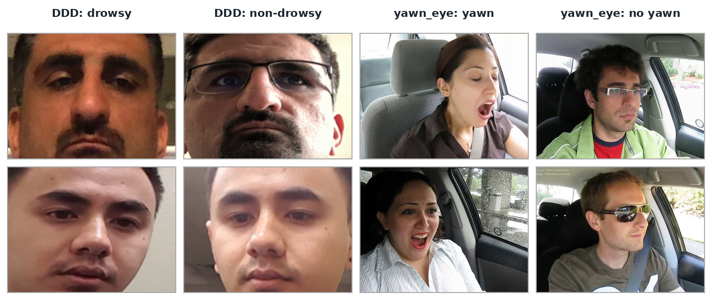
Fig. 2. Representative images from the submitted sample subsets. The figure illustrates DDD drowsy/non-drowsy and yawn/no-yawn variation; it is not an additional quantitative experiment.

4.2 Recorded Videos
Three participants each supplied an alert video and an acted-drowsiness video. The six videos contain 11,938 frames and 21 labeled events: 10 eye closures, five yawns, and six head tilts. Recording protocols were not standardized; frame rate, resolution, camera placement, performed behaviour, and annotation procedure differ across participants. Consequently, participant-specific results are treated as primary evidence and pooled results as supplementary summaries. The experiment has $N=3$ and cannot establish population-level generalization.
Table 2. Submitted-video metadata and labeled events.
Participant | Video | Frames | FPS | No-face | Eye | Yawn | Tilt
Binh | Alert | 1,351 | 16.6 | 0 | 0 | 0 | 0
Binh | Drowsy | 1,421 | 16.6 | 21 | 5 | 3 | 3
Kiet | Alert | 2,287 | 29.9 | 0 | 0 | 0 | 0
Kiet | Drowsy | 3,225 | 29.3 | 0 | 4 | 2 | 3
Ninh | Alert | 1,834 | 29.9 | 0 | 0 | 0 | 0
Ninh | Drowsy | 1,820 | 29.9 | 0 | 1 | 0 | 0
Total | Six videos | 11,938 | — | 21 | 10 | 5 | 6
Ground truth is represented by event type, start time, and end time. Frame-level evaluation compares every prediction with the active labeled interval. An event alert is matched when it overlaps at least 30% of a labeled interval. Each labeled interval can generate one hit; an unmatched label is a miss, and an unmatched alert is a false alarm.

4.3 Metrics and Implementation
Static and frame-level evaluation use accuracy, precision, recall, and F1-score. Event precision is $H/\left(H+F\right)$ and event recall is $H/\left(H+M\right)$, where $H$, $F$, and $M$ denote hits, false alarms, and misses. A metric is reported as not applicable when the required positive support is absent. Accuracy is interpreted together with precision, recall, F1, and event counts because negative video frames are the majority.
The verified interpreter was Python 3.11.9. Package versions were OpenCV 4.11.0, MediaPipe 0.10.21, NumPy 1.26.4, and Matplotlib 3.11.0. Shared configuration and temporal-logic modules are used by both real-time inference and evaluation programs.

5 Results and Discussion

5.1 Static-Image Evaluation
Table 3 reports the full-dataset results. DDD precision is high, but recall is 0.4673, so more than half of labeled drowsy images are missed. At MAR $>0.60$, no false positive occurs in yawn/no-yawn images, while 249 yawns are missed. Figure 3 shows that the main weakness in both tasks is false-negative detection rather than false positives.
Table 3. Full public-image dataset results using the final configuration.
Dataset | TP | TN | FP | FN | Acc. | Prec. | Recall | F1
DDD | 10,438 | 17,878 | 1,559 | 11,901 | .6778 | .8701 | .4673 | .6080
Yawn/no-yawn | 473 | 724 | 0 | 249 | .8278 | 1.0000 | .6551 | .7916
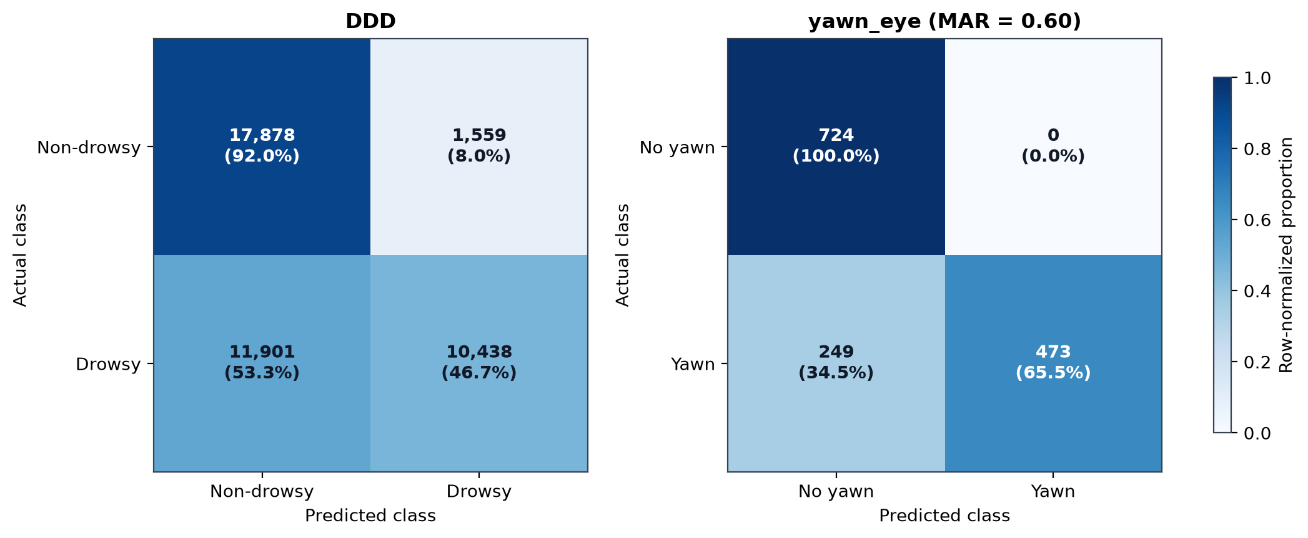
Fig. 3. Row-normalized confusion matrices on the full processed DDD and yawn/no-yawn datasets. Images without a detected face are excluded from the matrices and reported separately.
Lowering MAR from 0.60 to 0.45 increased yawn recall from 0.6551 to 0.8615 and F1 from 0.7916 to 0.9256 without a false positive on this static dataset. Nevertheless, 0.60 was retained as a conservative setting because static no-yawn images do not adequately represent speech, laughter, or other prolonged mouth movements that can occur in video.

5.2 EAR Configuration Analysis
Four EAR/duration settings were tested on one participant’s development videos (Table 4). All settings detected the five labeled eye-closure events. Configuration B reduced false alarms from 10 to six by increasing persistence from 0.67 to 1.00 s. Its frame F1 (0.6126) is slightly below the baseline (0.6274), so B is selected as a false-alarm/duration trade-off rather than an absolute optimum. Figure 4 visualizes both frame metrics and event errors. Because the comparison uses one participant, it is a sensitivity study, not evidence of general superiority.
Table 4. EAR and duration configurations on the development participant.
Config. | EAR | Duration | Hits | False alarms | Recall | F1
Baseline | .21 | .67 s | 5/5 | 10 | .6578 | .6274
A | .18 | .67 s | 5/5 | 7 | .4702 | .5338
B (selected) | .21 | 1.00 s | 5/5 | 6 | .5916 | .6126
C | .19 | .83 s | 5/5 | 6 | .4834 | .5455
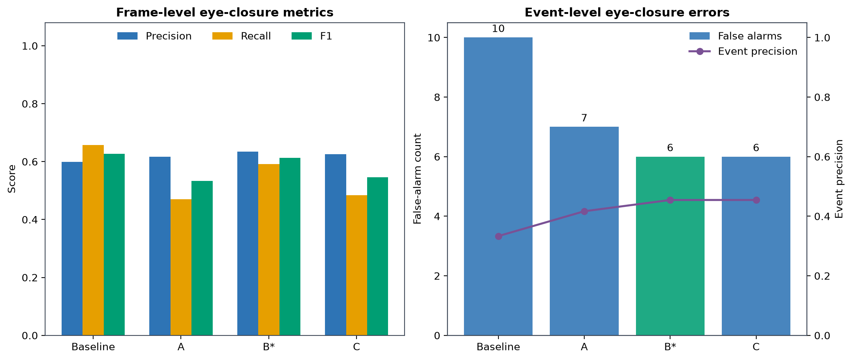
Fig. 4. Eye-closure frame metrics and event errors for four configurations. B* denotes the selected false-alarm/duration trade-off.

5.3 Video Results
Across all videos, the system detected eight of 10 eye closures, three of five yawns, and three of six head tilts (Table 5). Eye closure has the highest event recall but the lowest event precision because ten unmatched eye alerts were produced. Yawn detection is more conservative, while head-tilt precision and recall are both 0.50.
Table 5. Supplementary pooled event-level video results.
Event | GT | Hit | Miss | False alarm | Precision | Recall
Eye closure | 10 | 8 | 2 | 10 | .4444 | .8000
Yawn | 5 | 3 | 2 | 1 | .7500 | .6000
Head tilt | 6 | 3 | 3 | 3 | .5000 | .5000
Participant-specific event metrics in Fig. 5 provide the more informative comparison. Binh achieved complete eye/yawn recall but no head-tilt hit; Kiet achieved complete head-tilt recall but detected only half of eye closures and none of the labeled yawns; Ninh contributed one detected eye event and had no positive yawn or tilt support. An N/A cell is unsupported or undefined and must not be interpreted as a zero score.
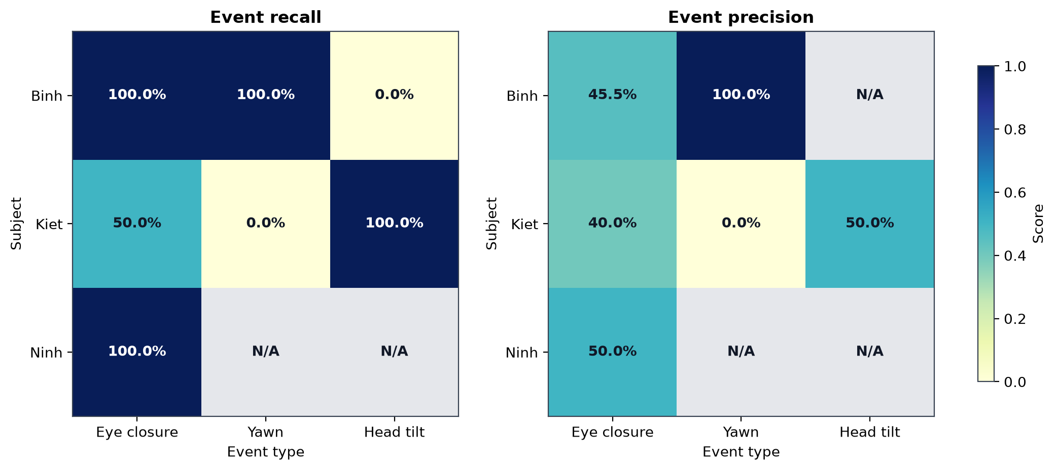
Fig. 5. Primary event-level recall and precision by participant. Differences reflect both system behaviour and non-standardized recording/annotation protocols; N/A denotes an unsupported or undefined metric.
Pooled frame-level F1 was 0.8398 for eye closure, 0.5118 for yawning, and 0.5507 for head tilt. The corresponding recall values were 0.7936, 0.3453, and 0.3964. Accuracy exceeded 0.92 for every cue because negative frames dominate, so it does not by itself establish reliable warning performance.

5.4 Failure Cases
The quantitative results identify several failure modes. DDD recall of 0.4673 shows that a fixed EAR threshold misses many labeled drowsy images. Eye closure produced ten event-level false alarms, which may be associated with squinting, landmark jitter, annotation timing, or a common threshold applied to different faces. MAR $=0.60$ reduces false positives but misses mouth openings that are not large or persistent enough. Roll-only geometry misses forward nodding when pitch changes without a large lateral eye-line angle. Finally, the Binh drowsy video contains 21 no-face frames (1.48%); each loss resets temporal state and can fragment a genuine event.
These explanations are hypotheses consistent with the measurements rather than controlled causal findings, because several recording factors changed at the same time. Before final submission, this subsection should include three to five authentic frames with video filename and timestamp: at least one eye false negative, one eye false alarm, one missed yawn, one forward-pitch miss, and one no-face example. No failure-case image should be staged or fabricated.

6 Limitations and Future Work
The video experiment contains only three participants and uses acted behaviours. FPS, resolution, camera placement, event performance, and annotation procedure were not standardized. Fixed thresholds may not transfer across facial geometry, eyewear, illumination, and camera viewpoints. Static image labels also do not represent the temporal context of a real warning. The method estimates roll but not full pitch/yaw, and loss of facial landmarks interrupts duration tracking. No learned baseline was evaluated under the same protocol.
Future work should standardize capture and annotation, recruit more participants, separate development and test participants, calibrate neutral EAR/MAR baselines per user, estimate full 3D head pose, and include natural speech and laughter as negative yawn examples. With a larger participant sample, evaluation should report participant-level macro averages and uncertainty rather than relying on pooled frames.

7 Conclusion
This paper presented an explainable driver-drowsiness prototype using pretrained facial landmarks, EAR, MAR, head roll, and duration measured in seconds. The system supports webcam inference and offline evaluation without training a new drowsiness classifier. Static results showed high precision but limited recall, and video evaluation showed that eye closure was detected more reliably than yawning or lateral head tilt. Increasing eye persistence reduced false alarms on the development participant, but performance varied strongly across the three participants. The current evidence supports a reproducible academic prototype, not deployment as a safety-critical driver-monitoring system.

References
- Albadawi, Y., AlRedhaei, A., Takruri, M.: Real-time machine learning-based driver drowsiness detection using visual features. Journal of Imaging 9(5), 91 (2023). https://doi.org/10.3390/jimaging9050091
- Alioua, N., Amine, A., Rziza, M.: Driver’s fatigue detection based on yawning extraction. International Journal of Vehicular Technology 2014, 678786 (2014). https://doi.org/10.1155/2014/678786
- Grishchenko, I., Ablavatski, A., Kartynnik, Y., Raveendran, K., Grundmann, M.: Attention mesh: High-fidelity face mesh prediction in real time. arXiv preprint arXiv:2006.10962 (2020). https://doi.org/10.48550/arXiv.2006.10962
- Kartynnik, Y., Ablavatski, A., Grishchenko, I., Grundmann, M.: Real-time facial surface geometry from monocular video on mobile GPUs. arXiv preprint arXiv:1907.06724 (2019). https://doi.org/10.48550/arXiv.1907.06724
- Kim, D., Park, H., Kim, T., Kim, W., Paik, J.: Real-time driver monitoring system with facial landmark-based eye closure detection and head pose recognition. Scientific Reports 13, 18264 (2023). https://doi.org/10.1038/s41598-023-44955-1
- Lugaresi, C., Tang, J., Nash, H., McClanahan, C., Uboweja, E., Hays, M., Zhang, F., Chang, C.-L., Yong, M.G., Lee, J., Chang, W.-T., Hua, W., Georg, M., Grundmann, M.: MediaPipe: A framework for perceiving and processing reality. In: Third Workshop on Computer Vision for AR/VR at IEEE CVPR (2019)
- Nasri, I.: Driver drowsiness dataset (DDD). Kaggle dataset (n.d.), https://www.kaggle.com/datasets/ismailnasri20/driver-drowsiness-dataset-ddd, accessed 21 July 2026
- Raju, S.: Yawn eye dataset – new. Kaggle dataset (n.d.), https://www.kaggle.com/datasets/serenaraju/yawn-eye-dataset-new, accessed 21 July 2026
- Sahayadhas, A., Sundaraj, K., Murugappan, M.: Detecting driver drowsiness based on sensors: A review. Sensors 12(12), 16937–16953 (2012). https://doi.org/10.3390/s121216937
- Sigari, M.-H., Fathy, M., Soryani, M.: A driver face monitoring system for fatigue and distraction detection. International Journal of Vehicular Technology 2013, 263983 (2013). https://doi.org/10.1155/2013/263983
- Soukupová, T., Čech, J.: Real-time eye blink detection using facial landmarks. In: Proceedings of the 21st Computer Vision Winter Workshop, pp. 1–8 (2016)
- Zhu, T., Zhang, C., Wu, T., Ouyang, Z., Li, H., Na, X., Liang, J., Li, W.: Research on a real-time driver fatigue detection algorithm based on facial video sequences. Applied Sciences 12(4), 2224 (2022). https://doi.org/10.3390/app12042224

Corresponding author.

